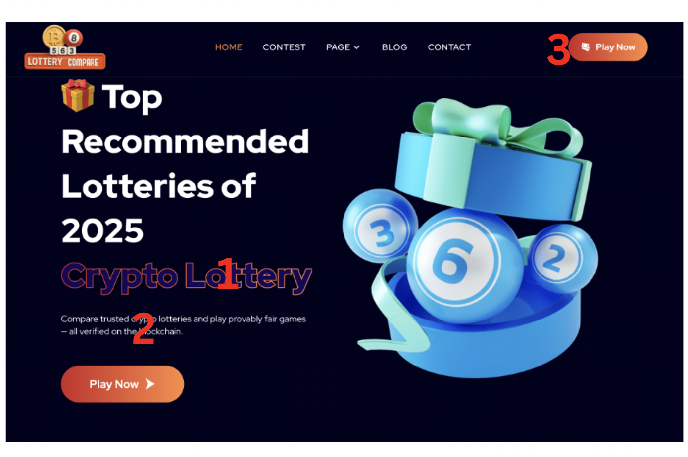

1. Change “crypto lottery” in purple and orange to: GUESS NUMBERS, WIN JACKPOT
2. Change compare trusted…. To:  
   Compare trusted and proven global lotteries   
   takeout “all verified on the blockchain
3. Change “Play Now” to “Compare” and have it link to the table
4. The Play Now Button at the bottom, take that off

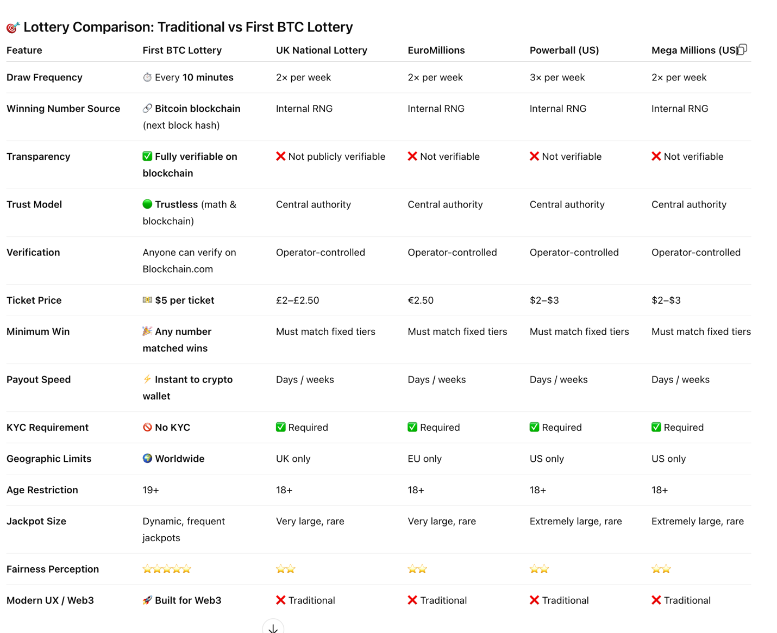

Change this table to the one above

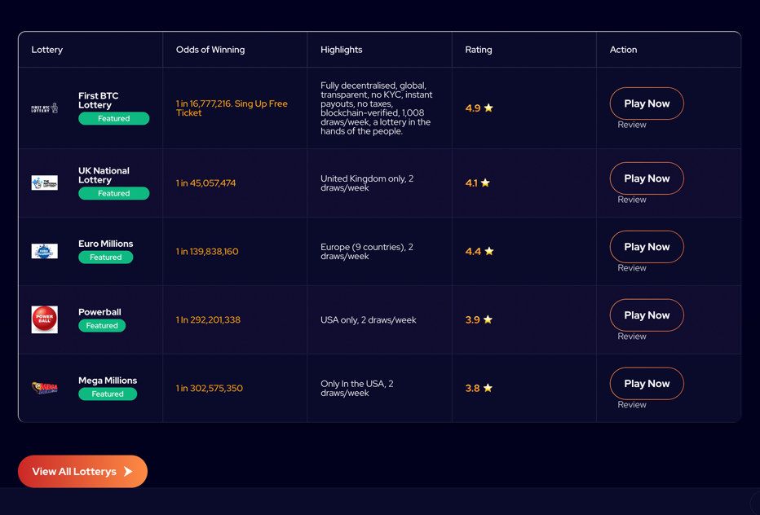

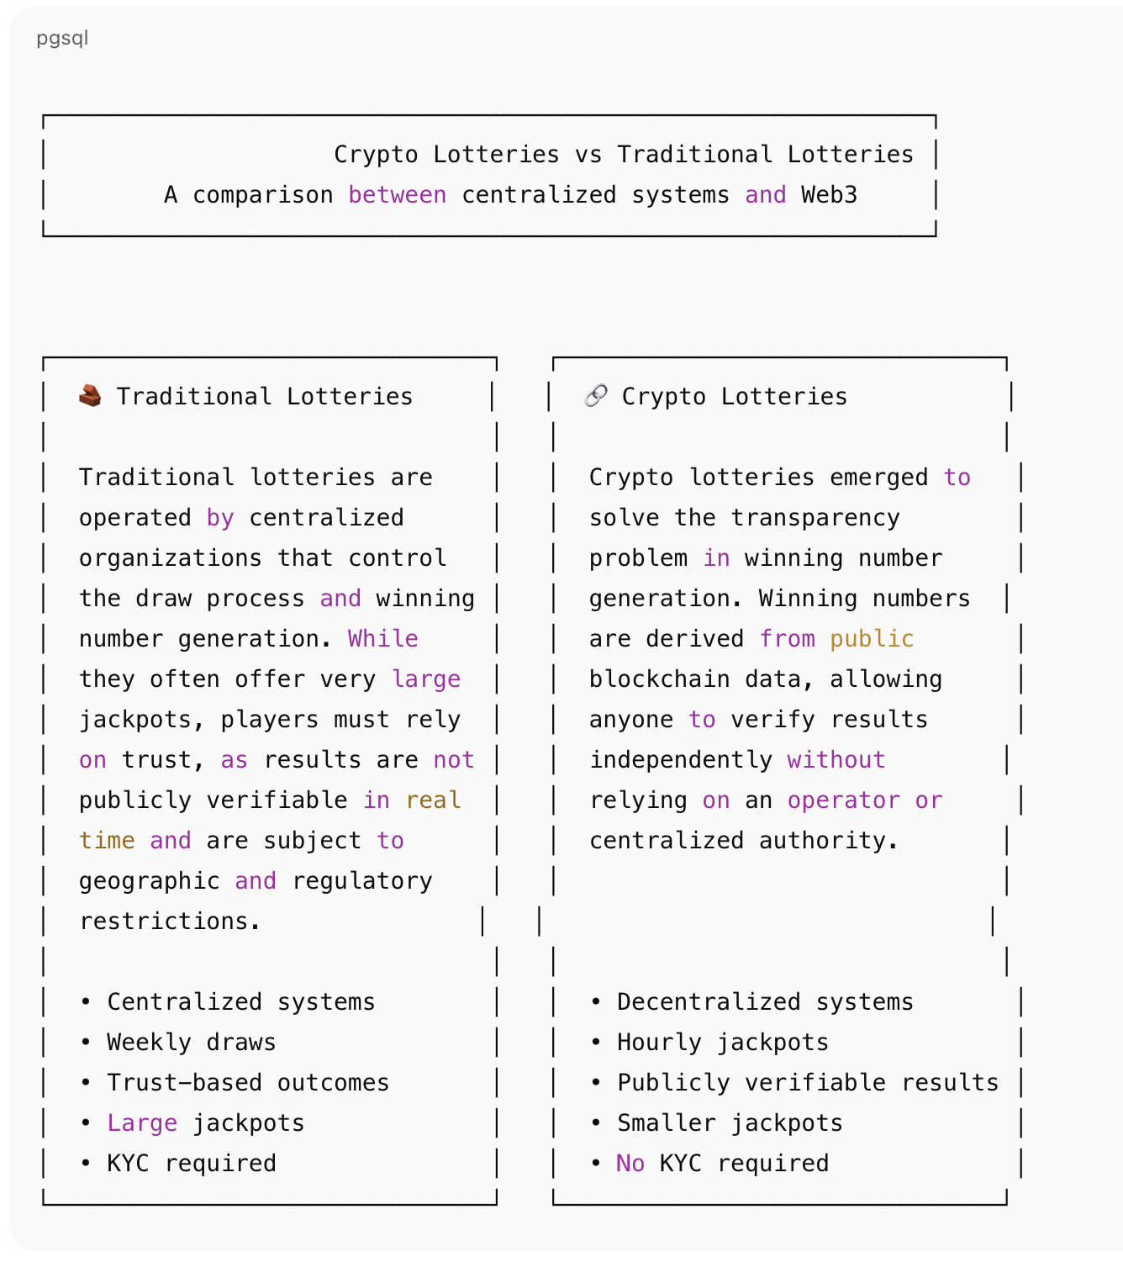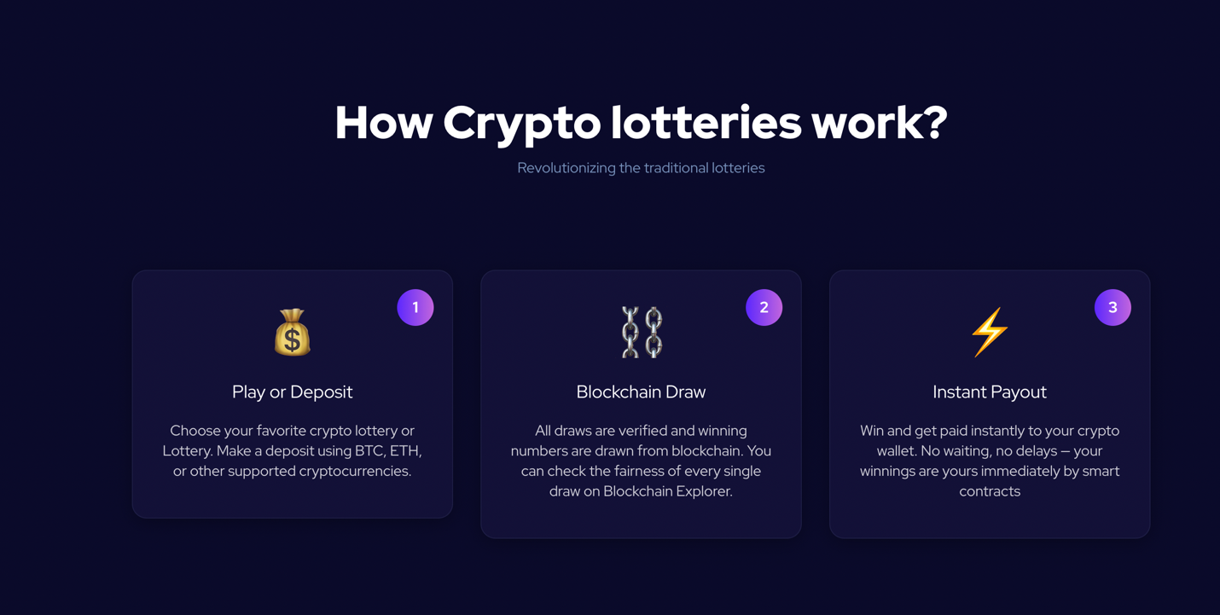

Replace this section with the above table

Take this section our entirelty and have a VS section like the column above.

For the “Featured Lottery Review Section”   
  
Have the Rating, Jackpot Odds, Jackpot Amount as 3 separate points   
+ Description

**🇬🇧 UK National Lottery (Lotto)**

**Rating:** ⭐⭐⭐⭐☆ (4.2 / 5)

**Description**  
Government-run UK lottery with twice-weekly draws, centralized number generation, and large rollovers. Proceeds support public projects and charities.

**Jackpot Odds:**  
1 in **45,000,000**

**Typical Jackpot:**  
£2M minimum, commonly **£5M–£15M**

## 🇪🇺 EuroMillions

**Rating:** ⭐⭐⭐⭐☆ (4.1 / 5)

**Description**  
Pan-European lottery offering massive rollover jackpots, twice-weekly draws, and centralized systems operated by national lottery organizations.

**Jackpot Odds:**  
1 in **139,000,000**

**Typical Jackpot:**  
€17M minimum, capped at **€240M**

## 🇺🇸 Powerball

**Rating:** ⭐⭐⭐⭐☆ (4.0 / 5)

**Description**  
Iconic US lottery famous for record-breaking jackpots, frequent rollovers, three weekly draws, and extremely low odds of winning the top prize.

**Jackpot Odds:**  
1 in **292,000,000**

**Typical Jackpot:**  
$20M minimum, often **$300M–$1B+**

## 🇺🇸 Mega Millions

**Rating:** ⭐⭐⭐⭐☆ (3.9 / 5)

**Description**  
Major US lottery known for enormous jackpots, twice-weekly draws, centralized number selection, and some of the longest odds in global lottery games.

**Jackpot Odds:**  
1 in **302,000,000**

**Typical Jackpot:**  
$20M minimum, frequently **$200M–$1B+**

## 🟣 First BTC Lottery

**Rating:** ⭐⭐⭐⭐⭐ (4.8 / 5)

**Description**  
Blockchain-based lottery with frequent draws, transparent number generation from public Bitcoin data, and instant crypto payouts without traditional lottery restrictions.

**Jackpot Odds:**  
1 in 16,000,000

**Typical Jackpot:**  
Typically $80,000, but even 2 digits win, **updated every draw**

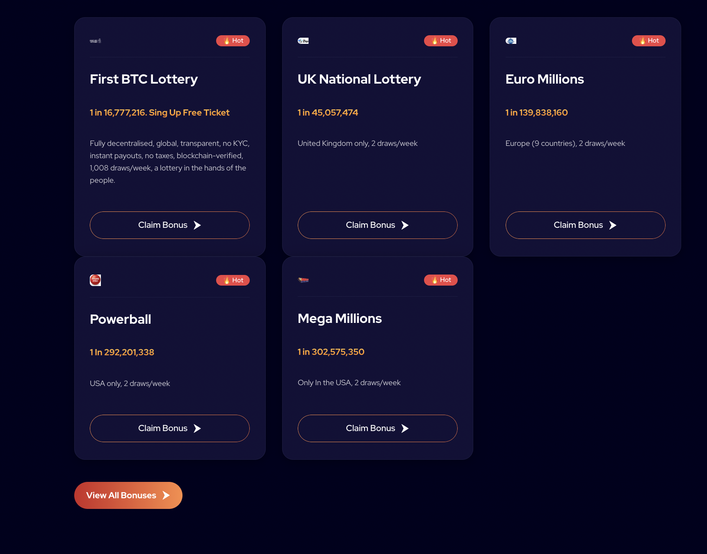

Take this section out, its repetitive



Delete Contest page entirely



Make the Font size bigger

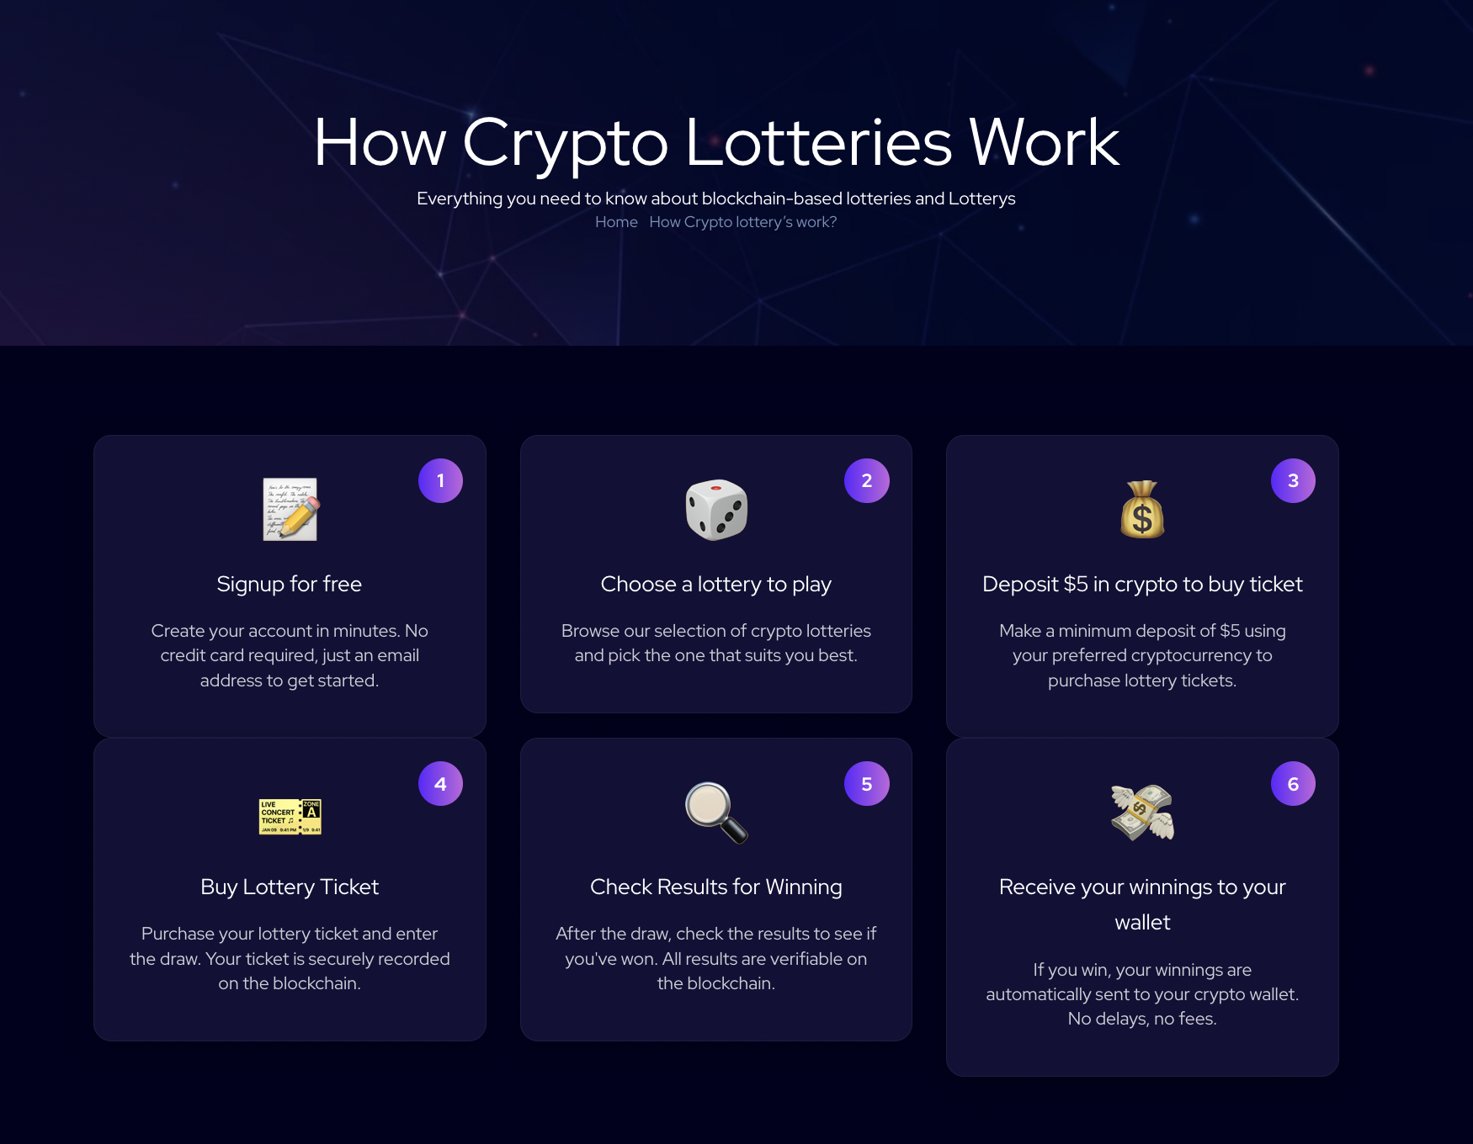

Design of the cards are overlapping

Number 3 and 6

Number 1 and 4

Only 2 and 5 look normal



The “play now” on how it works page doesn’t work

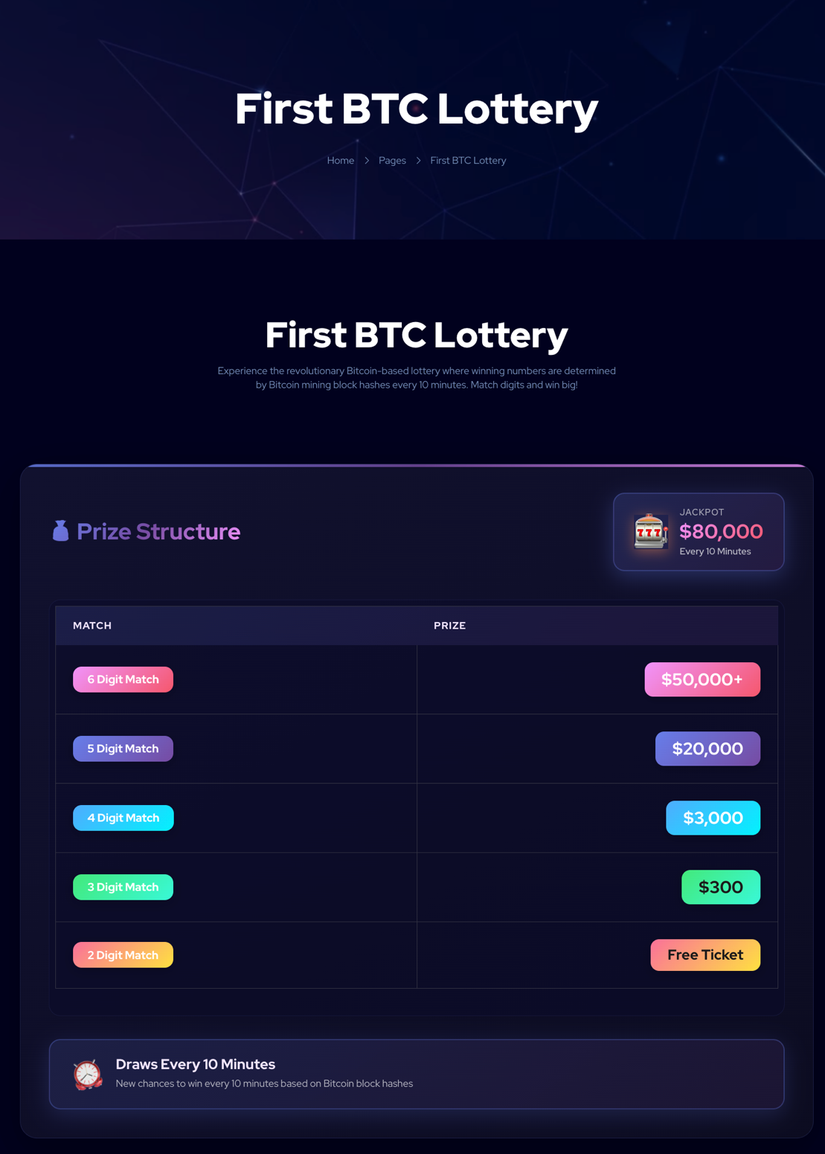

On the page “First BTC Lottery” have a play now button that takes you to the site



Delete : “Check the latest completed lottery draws and winning numbers”   
instead write: View some of First BTC Lottery Results, for more updated ones, check their site as there is a winner every 10 minutes.